How to pay bill by a Patient from an invoice

1. Create a customer without Guarantor (Ex-12155)

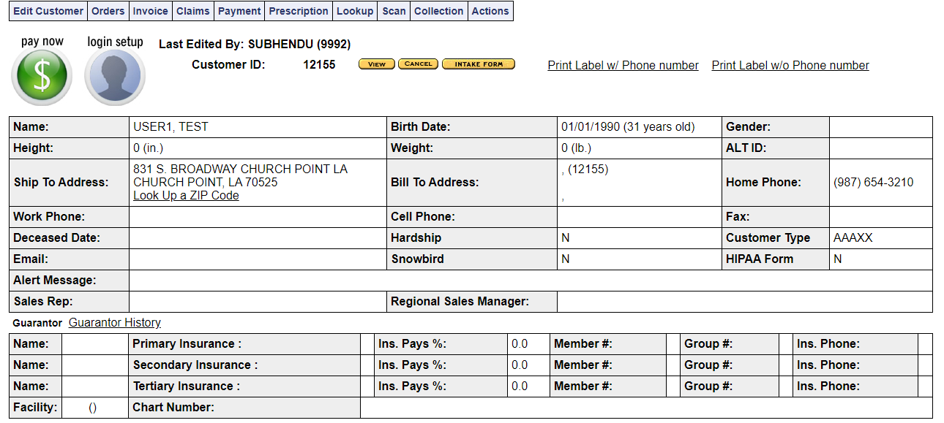

1. Create an order by the same customer(Ex-7910)

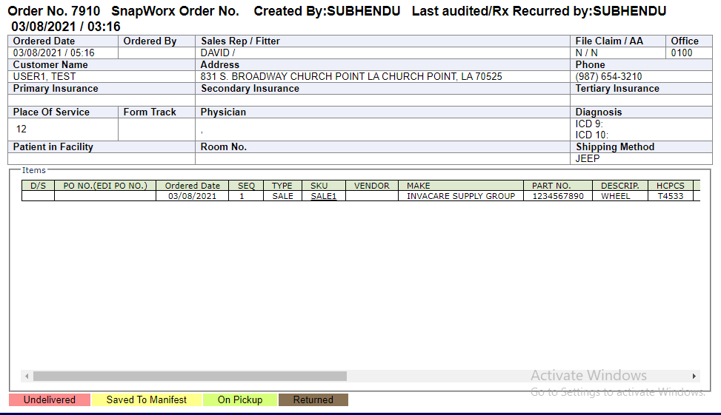

1. Generate the invoice of same order(Ex-10492)
2. Click on “Payment & Transaction” from left hand side “Activities” menu

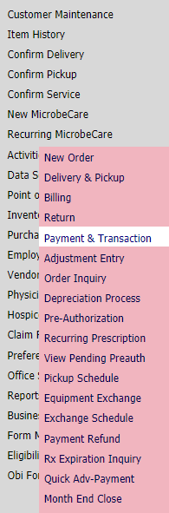

1. Select “Invoice Payment” from “Select a Transaction type” drop down and click on “Next Step” button.

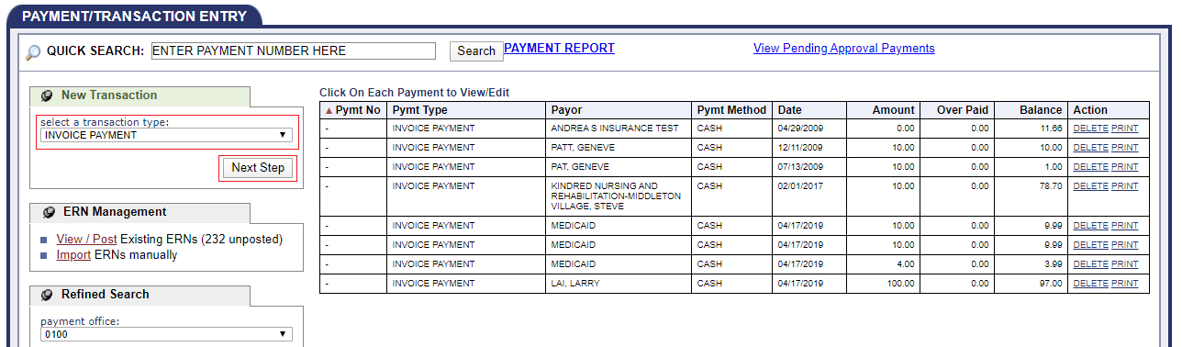

1. Enter same Order/Invoice number and click on “Look Up” button

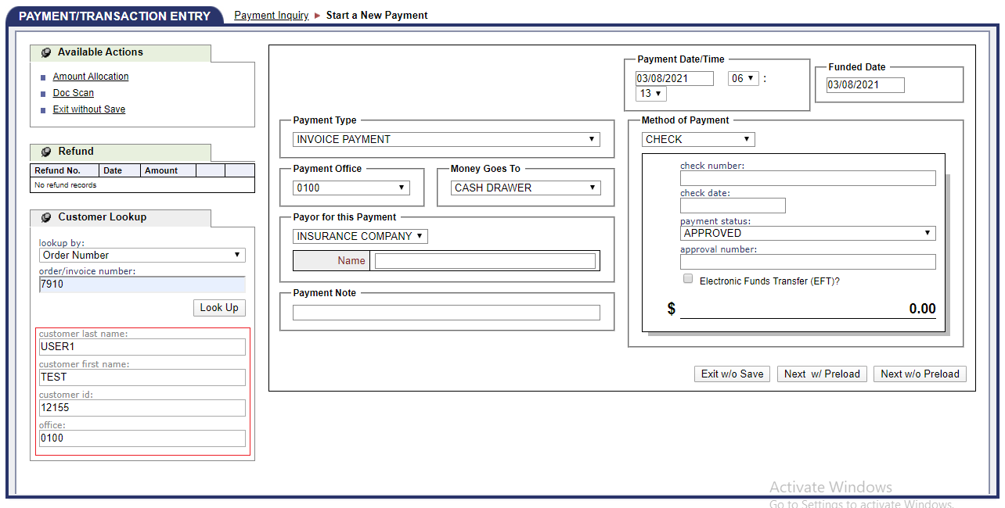

1. Customer details will come up
2. Select “Customer from” from “Payer for this Payment” drop down, Enter the “Bill-To ID” and select it from auto-suggestion, Select any payment method from “Method of Payment” drop down , enter the payment amount and click on “New w/ Preload” button.

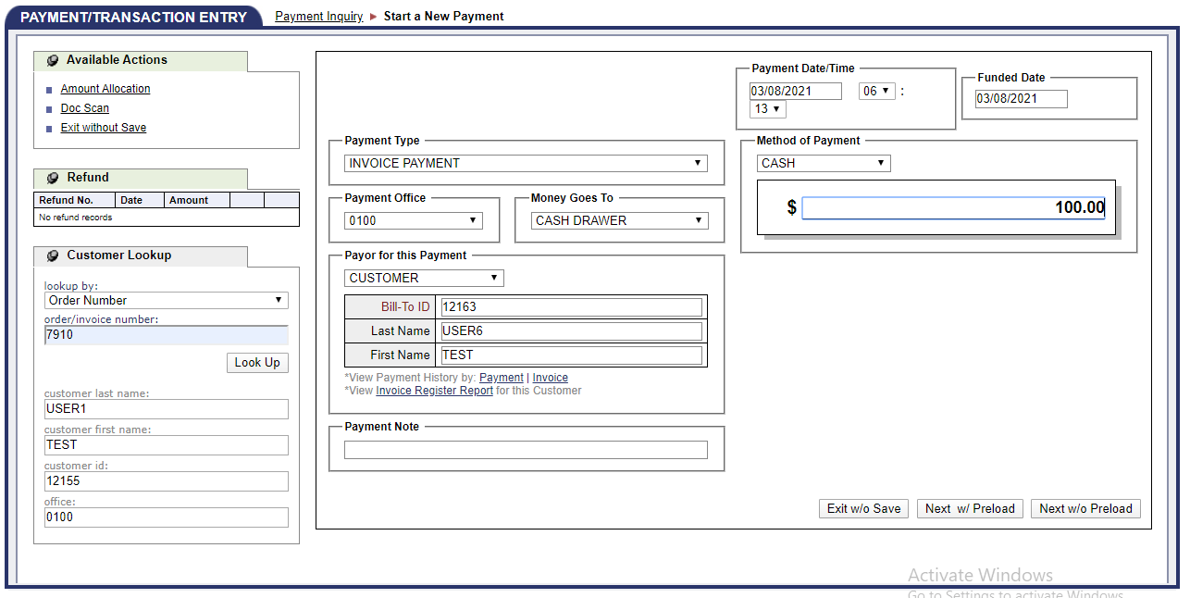

1. Search the same order number

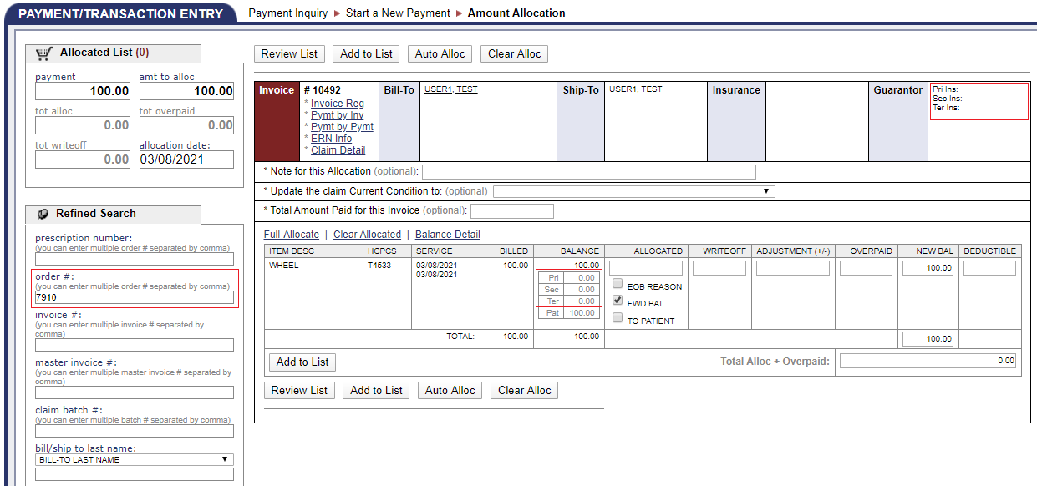

1. You will able to all the guarantor amount to is “Zero” and whole order amount is assigned to Patient.
2. Check the ” To Patient” checkbox and click on “Auto Alloc” button.

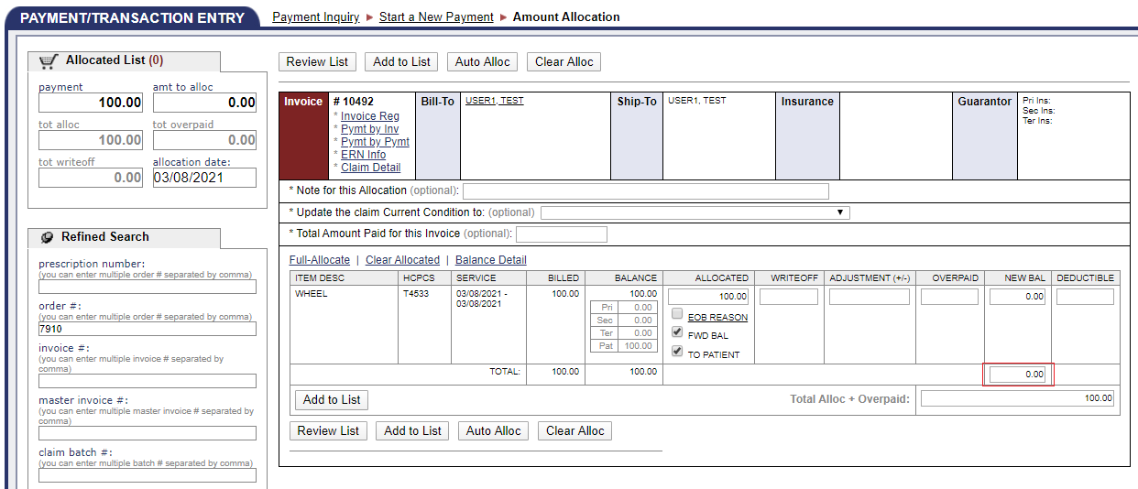

Now you should see New BAL is Zero